- Introduction

Primary Current Injection Test Set is the necessary equipment in places of strong current. It is widely used in power plants, power distribution stations, electrical manufacturers, research institutes and other departments. The equipment has the characters of short-term or intermittent system, small size, light weight and easy maintenance and so on.

Structure

The product has full metal shell and aluminum-alloy panel combination with reasonable structure, elegant appearance, light weight and easy move.
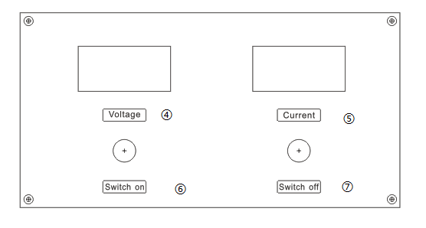
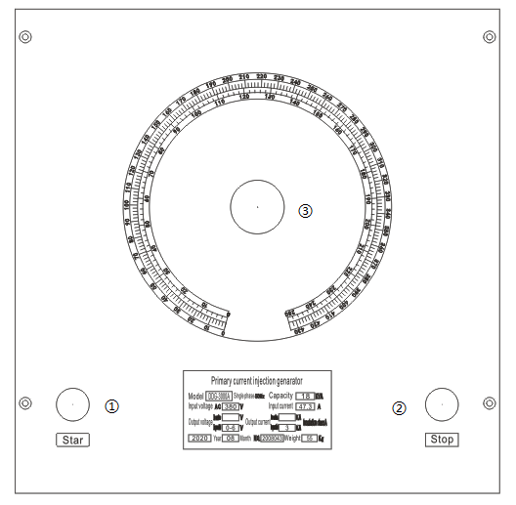

1: Start Button 2: Stop Button 3: Current Regulation Handle
4:Voltage Switch 5: Current Switch 6: switch on 7: switch off

Technical Parameters and Specifications

  - Input Voltage: 220V,single phase 2.Capacitance: 18KVA
3.Primary Voltage:220V; Secondary Voltage: 6V 4.Primary Current:81.8A,Secondary Current: 3000A 5.Voltage/current accracy: 1.5% 6.G.Weight/N.Weight:90gks
7:Packing (Plywood case) size:500x720x865mm 8.Full load time should not exceed 5 minutes,
continuous work time should be less than 2.5 minutes, but the working cycle should be more than 10 minutes.

Instructions
- Connect the current amplifier with the tested product according to the testing requirements, and make sure that there’s power supply. (For split type, connect the “input” on the panel with the power, the “output” with the “input” on DDK, and the “instrument” with the “instrument” on DDK.
- Select the position of Current Switch according to the needed current.
- Turn on the power, and the green light should be on (if not, turn the Voltage Switch counterclockwise to zero until the green light is on). Press the Startup Button, the green light should be off and the red light is on. Turn the Voltage Switch clockwise until the current rises to the needed level.
- Turn the Voltage Switch counterclockwise to zero, press the Stop Button, the red light is off and the green light is on. The testing is over.

Electrical Diagram

  - Diagram of Current Generator
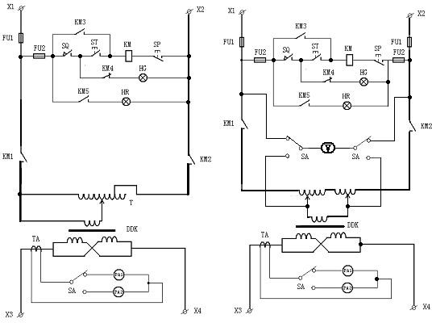
Current Amplifier Sketch Current Amplifier Sketch (Below 1000A) (Above 1000A)

  - Output copper wires connection method at open-backed door:

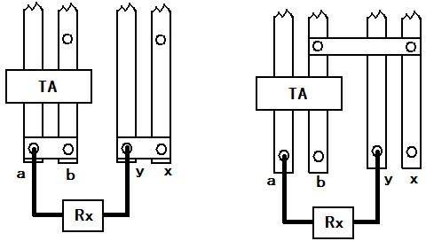
Connection in Parallel Connection in Series

